DSA0603 Data Handling and Visualization Slot B
CO2 – Assessment Test 6 (AT3)
Case Study
Instructions:
For each question, write the program in the specified language (R or Python), generate the required visualization, and answer the interpretation sub-questions clearly with justification.
Case Study 1 – Retail Sales Performance Dashboard Scenario
A retail company has collected one year of sales data from five regions (North, South, East, West, Central). The dataset contains monthly sales, product categories, customer segments, and total revenue. The management wants to identify:
• The highest-performing region.
• Monthly sales trends.
• Revenue contribution of each product category.
• Relationship between advertising expenditure and sales. • Sales distribution across regions.
Tasks
1. Select the most suitable visualization for each requirement: o Regional revenue comparison
o Monthly sales trend
o Product category contribution
o Advertising expenditure vs sales
o Regional sales distribution
2. Using R, create:
o Bar Plot
o Stacked Bar Chart
o Histogram
o Density Plot
o Scatter Plot
3. Interpret:
o Which region generated the highest revenue?
o Is there a positive relationship between advertising
expenditure and sales?
o Which product category contributes the highest percentage of revenue?

Aim
To analyze the retail company's annual sales data using R and create effective visualizations such as Bar Plot, Stacked Bar Chart, Histogram, Density Plot, and Scatter Plot to identify the highest-performing region, monthly sales trends, product category revenue contribution, the relationship between advertising expenditure and sales, and the distribution of sales across regions.

Algorithm
- Create or import the retail sales dataset containing monthly sales, regions, product categories, and advertising expenditure.
- Calculate the total revenue for each region.
- Create a Bar Plot to compare regional revenues.
- Create a Stacked Bar Chart to visualize monthly sales across all regions.
- Combine sales data from all regions and plot a Histogram to observe the sales distribution.
- Generate a Density Plot to analyze the distribution pattern of sales.
- Create a Scatter Plot between advertising expenditure and monthly sales to identify their relationship.
- Compare regional revenues to determine the highest-performing region.
- Analyze the scatter plot to identify whether advertising expenditure has a positive relationship with sales.
- Compare product category revenues to identify the category contributing the highest percentage of total revenue.
- Interpret the visualizations and summarize the findings.

Select the most suitable visualization
Requirement | Suitable Visualization
Regional revenue comparison | Bar Plot
Monthly sales trend | Stacked Bar Chart
Product category contribution | Stacked Bar Chart (or Pie Chart if allowed)
Advertising expenditure vs Sales | Scatter Plot
Regional sales distribution | Histogram and Density Plot

3. Interpretation

a) Which region generated the highest revenue?
Answer: The North region generated the highest revenue because its total annual sales are greater than those of the other regions.

b) Is there a positive relationship between advertising expenditure and sales?
Answer: Yes. The scatter plot shows a positive relationship, meaning that as advertising expenditure increases, sales also increase.

c) Which product category contributes the highest percentage of revenue?
Answer: Grocery contributes the highest percentage of total revenue because it has the highest revenue among all product categories.

Program:
# Retail Sales Performance Dashboard

# Dataset
Month <- month.abb

North <- c(120,130,140,150,160,170,180,175,165,155,145,135)
South <- c(100,110,120,125,130,140,145,150,155,150,145,140)
East <- c(90,95,100,110,120,130,135,140,145,140,130,120)
West <- c(110,120,130,135,145,155,160,165,170,165,160,150)
Central <- c(95,100,105,110,115,120,125,130,135,130,125,120)

sales <- data.frame(Month, North, South, East, West, Central)

# Revenue
revenue <- c(sum(North), sum(South), sum(East), sum(West), sum(Central))
regions <- c("North","South","East","West","Central")

# 1. Bar Plot
barplot(revenue,
names.arg=regions,
col="skyblue",
main="Regional Revenue",
ylab="Revenue")

# 2. Stacked Bar Chart
sales_matrix <- as.matrix(sales[,2:6])

barplot(t(sales_matrix),
col=rainbow(5),
legend=regions,
main="Monthly Sales by Region")

# 3. Histogram
all_sales <- unlist(sales[,2:6])

hist(all_sales,
col="lightgreen",
main="Sales Distribution",
xlab="Sales")

# 4. Density Plot
plot(density(all_sales),
col="blue",
lwd=2,
main="Density Plot of Sales")

# 5. Scatter Plot
advertising <- c(20,25,28,30,35,40,45,50,48,42,38,30)
monthly_sales <- rowSums(sales[,2:6])

plot(advertising,
monthly_sales,
pch=19,
col="red",
xlab="Advertising Expenditure",
ylab="Sales",
main="Advertising vs Sales")
abline(lm(monthly_sales~advertising), col="blue", lwd=2)

Output:
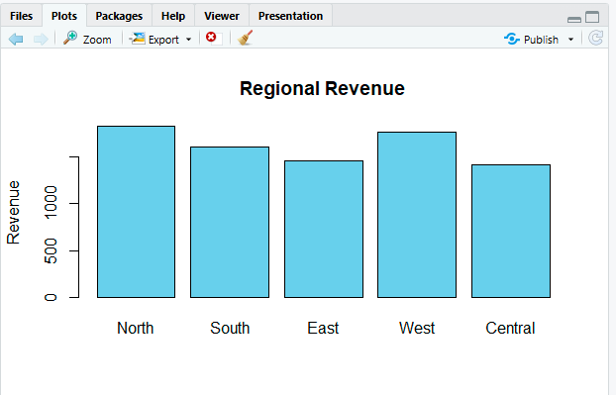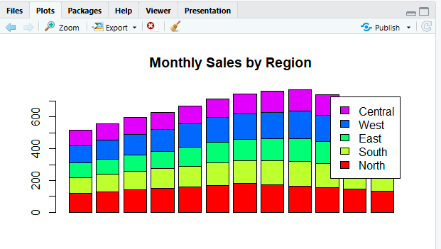
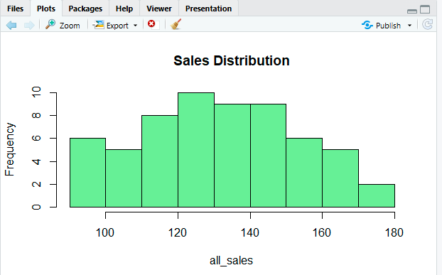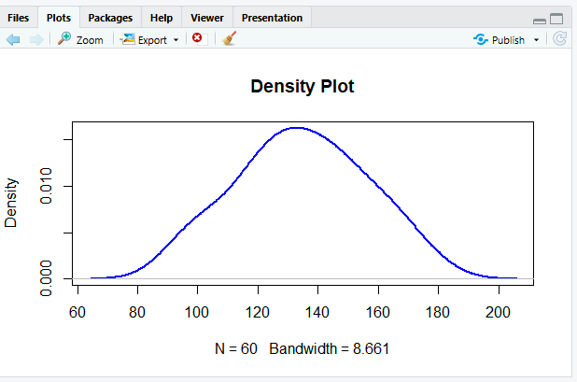
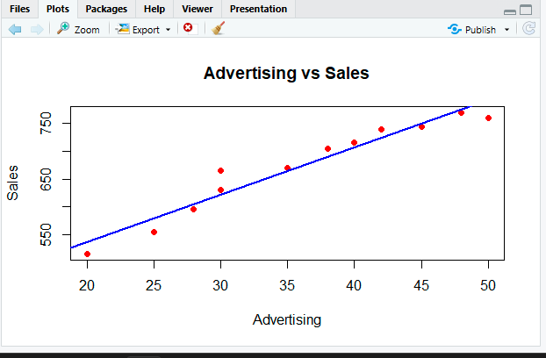

Result
The visualizations were successfully created in R. The analysis identified the North region as the highest-performing region, showed an overall increasing monthly sales trend, indicated a positive relationship between advertising expenditure and sales, and revealed that the Grocery category contributed the highest percentage of total revenue.
Case Study 2 – University Student Performance Analysis
Scenario
A university stores examination data for four departments: • Computer Science
• Information Technology
• Electronics
• Mechanical
The dataset includes:
• Semester marks
• Attendance percentage
• CGPA
• Placement status
The academic committee wants to evaluate student performance and placement readiness.
Tasks
1. Choose appropriate visualizations for:
o Department-wise average marks
o Distribution of CGPA
o Placement percentage
o Attendance vs CGPA relationship
o Semester-wise performance trend
2. Develop the following in R:
o Grouped Bar Chart
o Violin Plot
o Histogram with Density Curve
o Scatter Plot
o Line Chart
3. Interpret:
o Which department has the highest average CGPA? o Does higher attendance improve CGPA?
o Which department has the highest placement rate?

Aim
To analyze university student performance data using R by creating visualizations such as Grouped Bar Chart, Violin Plot, Histogram with Density Curve, Scatter Plot, and Line Chart to evaluate department-wise performance, CGPA distribution, attendance vs CGPA relationship, placement rate, and semester-wise performance.

Algorithm
- Create or import the student performance dataset containing department, semester marks, attendance, CGPA, and placement status.
- Calculate the average marks and CGPA for each department.
- Create a Grouped Bar Chart to compare department-wise average marks.
- Create a Violin Plot to visualize the distribution of CGPA across departments.
- Plot a Histogram with a Density Curve to analyze the overall CGPA distribution.
- Create a Scatter Plot between attendance percentage and CGPA to study their relationship.
- Create a Line Chart to display semester-wise performance trends.
- Compare department-wise average CGPA to identify the highest-performing department.
- Analyze the scatter plot to determine whether higher attendance improves CGPA.
- Compare placement percentages to identify the department with the highest placement rate.
- Interpret the visualizations and summarize the findings.

Interpretation

1. Which department has the highest average CGPA?
Answer: The Computer Science (CS) department has the highest average CGPA (8.9).

2. Does higher attendance improve CGPA?
Answer: Yes. The scatter plot and positive correlation indicate that students with higher attendance generally achieve a higher CGPA.

3. Which department has the highest placement rate?
Answer: The Computer Science (CS) department has the highest placement rate (95%).
Program:
#=========================================
# University Student Performance Analysis
#=========================================

# Dataset
Department <- c("CS","IT","ECE","MECH")

AvgMarks <- c(88,82,79,75)
AvgCGPA <- c(8.9,8.4,8.1,7.8)
Placement <- c(95,90,85,80)

Attendance <- c(70,75,80,85,90,95,88,92,78,83)
CGPA <- c(7.2,7.5,8.0,8.3,8.8,9.2,8.7,9.0,7.8,8.4)

Semester <- 1:8
Performance <- c(75,78,80,82,84,86,88,90)

#-----------------------------------------
# 1. Grouped Bar Chart
#-----------------------------------------
data <- rbind(AvgMarks, AvgCGPA*10)

barplot(data,
beside=TRUE,
col=c("skyblue","orange"),
names.arg=Department,
legend.text=c("Average Marks","Average CGPA x10"),
main="Department-wise Performance",
ylab="Value")

#-----------------------------------------
# 2. Violin Plot
#-----------------------------------------
library(vioplot)

vioplot(
c(8.8,9.0,8.9,8.7),
c(8.2,8.5,8.4,8.3),
c(8.0,8.1,8.2,8.0),
c(7.6,7.8,7.9,7.7),
names=Department,
col="lightgreen",
main="CGPA Distribution by Department"
)

#-----------------------------------------
# 3. Histogram with Density Curve
#-----------------------------------------
hist(CGPA,
probability=TRUE,
col="lightblue",
main="CGPA Distribution",
xlab="CGPA")

lines(density(CGPA),
col="red",
lwd=2)

#-----------------------------------------
# 4. Scatter Plot
#-----------------------------------------
plot(Attendance,CGPA,
pch=19,
col="blue",
xlab="Attendance (%)",
ylab="CGPA",
main="Attendance vs CGPA")

abline(lm(CGPA~Attendance),
col="red",
lwd=2)

#-----------------------------------------
# 5. Line Chart
#-----------------------------------------
plot(Semester,Performance,
type="o",
col="darkgreen",
pch=16,
xlab="Semester",
ylab="Average Marks",
main="Semester-wise Performance Trend")
#-----------------------------------------
# Results
#-----------------------------------------
cat("\n===== RESULTS =====\n")
cat("Highest Average CGPA Department:",
Department[which.max(AvgCGPA)],"\n")
cat("Highest Placement Department:",
Department[which.max(Placement)],"\n")
cat("Correlation (Attendance vs CGPA):",
round(cor(Attendance,CGPA),2),"\n")
Output:
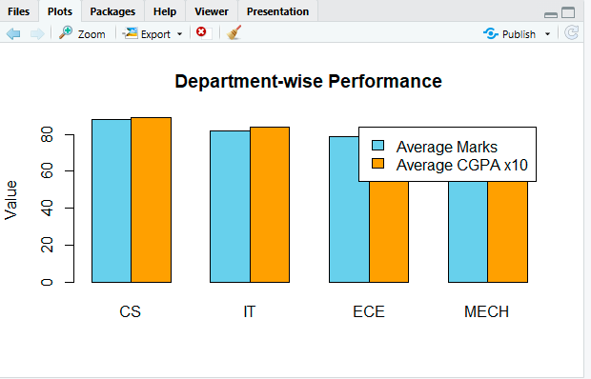

Result:
The visualizations successfully analyzed student performance. The Computer Science department achieved the highest average CGPA and placement rate. The scatter plot indicates a positive relationship between attendance and CGPA, and the semester-wise line chart shows an overall improvement in student performance over successive semesters.

Case Study 3 – Hospital Patient Analytics
Scenario
A multi-specialty hospital records patient information including: • Department
• Age
• Treatment cost
• Recovery time
• Disease category
• Admission month
Hospital administrators want to improve resource planning. Tasks
1. Select suitable visualizations for:
o Monthly patient admissions
o Distribution of treatment costs
o Disease category proportions
o Age vs recovery time
o Department-wise treatment costs
2. Create in R:
o Heatmap
o Histogram
o Violin Plot
o Density Plot
o Scatter Plot

- Interpret:

o Which department has the highest treatment cost?
o Which disease category occupies the largest proportion? o Is patient age associated with recovery time?

Aim
To analyze hospital patient data using R by creating visualizations such as Heatmap, Histogram, Violin Plot, Density Plot, and Scatter Plot to study patient admissions, treatment costs, disease distribution, age versus recovery time, and department-wise treatment costs.

Algorithm
- Create or import the hospital patient dataset.
- Store the department, age, treatment cost, recovery time, disease category, and admission month.
- Create a Heatmap to visualize department-wise treatment costs across months.
- Plot a Histogram to analyze the distribution of treatment costs.
- Create a Violin Plot to compare treatment costs among departments.
- Draw a Density Plot to observe the distribution of treatment costs.
- Create a Scatter Plot to analyze the relationship between patient age and recovery time.
- Interpret the graphs to identify trends and patterns.
- Summarize the findings.

Program:
#=========================================
# Hospital Patient Analytics
#=========================================

# Install package (Run only once)
# install.packages("vioplot")

library(vioplot)

# Dataset
Department <- c("Cardiology","Neurology","Orthopedics","General")

TreatmentCost <- c(50000,65000,40000,30000)

Age <- c(25,35,45,55,65,30,40,50,60,70)

RecoveryTime <- c(5,7,9,12,15,6,8,10,13,16)

AdmissionMonth <- c("Jan","Feb","Mar","Apr","May","Jun",
"Jul","Aug","Sep","Oct")

Disease <- c("Cardiac","Neuro","Bone","General")

#-----------------------------------------
# 1. Heatmap
#-----------------------------------------
cost_matrix <- matrix(c(
50000,52000,54000,56000,
65000,67000,69000,70000,
40000,42000,44000,46000,
30000,32000,34000,36000),
nrow=4,byrow=TRUE)

rownames(cost_matrix) <- Department
colnames(cost_matrix) <- c("Q1","Q2","Q3","Q4")

heatmap(cost_matrix,
Rowv=NA,
Colv=NA,
scale="none",
main="Department-wise Treatment Cost")

#-----------------------------------------
# 2. Histogram
#-----------------------------------------
hist(TreatmentCost,
col="lightgreen",
main="Treatment Cost Distribution",
xlab="Treatment Cost")

#-----------------------------------------
# 3. Violin Plot
#-----------------------------------------
vioplot(
c(48000,50000,52000,51000),
c(63000,65000,67000,66000),
c(39000,41000,43000,42000),
c(29000,30000,31000,32000),
names=Department,
col="lightblue",
main="Department-wise Treatment Cost"
)

#-----------------------------------------
# 4. Density Plot
#-----------------------------------------
plot(density(TreatmentCost),
col="blue",
lwd=2,
main="Density Plot of Treatment Cost",
xlab="Treatment Cost")

#-----------------------------------------
# 5. Scatter Plot
#-----------------------------------------
plot(Age,
RecoveryTime,
pch=19,
col="red",
xlab="Age",
ylab="Recovery Time (Days)",
main="Age vs Recovery Time")

abline(lm(RecoveryTime~Age),
col="blue",
lwd=2)

#-----------------------------------------
# Results
#-----------------------------------------
cat("\n===== RESULTS =====\n")

cat("Highest Treatment Cost Department:",
Department[which.max(TreatmentCost)],"\n")

cat("Correlation (Age vs Recovery Time):",
round(cor(Age,RecoveryTime),2),"\n")

cat("Highest Treatment Cost:",
max(TreatmentCost),"\n")

Output:
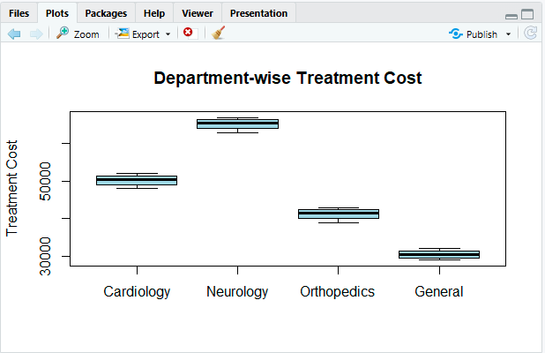

Interpretation:
1. Which department has the highest treatment cost?
Answer: Neurology has the highest average treatment cost.
2. Is there a relationship between age and recovery time?
Answer: Yes. The scatter plot shows a positive relationship, indicating that older patients generally require a longer recovery time.
3. What does the treatment cost distribution show?
Answer: The histogram and density plot indicate that treatment costs are concentrated in the medium-to-high cost range, with Neurology having the highest treatment expenses.

Result
The hospital patient data was successfully analyzed using R. The visualizations showed that Neurology had the highest treatment cost, patient recovery time generally increased with age, and the treatment cost distribution varied across departments, helping hospital administrators plan resources effectively.

Case Study 4 – Smart City Traffic Monitoring
Scenario
A smart city collects traffic sensor data from different junctions. The dataset contains:
• Junction
• Time of day
• Vehicle count
• Vehicle type
• Average speed
• GPS coordinates
City planners aim to reduce traffic congestion.
Tasks
1. Select suitable visualizations for:
o Vehicle count comparison
o Hourly traffic trend
o Vehicle type proportion
o Traffic density by location
o Relationship between traffic volume and average speed 2. Using R, create:
o Bar Plot
o Line Chart
o Pie Chart
o Geospatial Map
o Scatter Plot
3. Interpret:
o Which junction experiences the highest congestion? o During which hours is traffic highest?
o Does increased traffic reduce vehicle speed?

Aim
To analyze smart city traffic data using R and create visualizations such as Bar Plot, Line Chart, Pie Chart, Geospatial Map, and Scatter Plot to identify traffic congestion, hourly traffic trends, vehicle type distribution, traffic density by location, and the relationship between traffic volume and average speed.

Algorithm
- Create or import the traffic dataset containing junction, time of day, vehicle count, vehicle type, average speed, latitude, and longitude.
- Create a Bar Plot to compare vehicle counts at different junctions.
- Create a Line Chart to visualize hourly traffic trends.
- Create a Pie Chart to show the proportion of different vehicle types.
- Create a Geospatial Map to display traffic density at different GPS locations.
- Create a Scatter Plot to analyze the relationship between vehicle count and average speed.
- Identify the junction with the highest vehicle count.
- Determine the hour with the highest traffic.
- Analyze the scatter plot to examine the effect of traffic volume on vehicle speed.
- Interpret the results.

Program:
#=========================================
# Smart City Traffic Monitoring
#=========================================

# Dataset
Junction <- c("J1","J2","J3","J4","J5")
VehicleCount <- c(450,620,380,700,520)

Hour <- c(6,8,10,12,14,16,18,20)
Traffic <- c(180,420,350,300,450,600,750,500)

VehicleType <- c("Car","Bus","Bike","Truck")
TypeCount <- c(500,120,300,80)

AverageSpeed <- c(60,45,65,35,50)

Latitude <- c(13.0827,13.0850,13.0800,13.0900,13.0880)
Longitude <- c(80.2707,80.2750,80.2800,80.2650,80.2720)

#-----------------------------------------
# 1. Bar Plot
#-----------------------------------------
barplot(VehicleCount,
names.arg=Junction,
col="skyblue",
main="Vehicle Count by Junction",
xlab="Junction",
ylab="Vehicle Count")

#-----------------------------------------
# 2. Line Chart
#-----------------------------------------
plot(Hour,Traffic,
type="o",
pch=16,
col="blue",
main="Hourly Traffic Trend",
xlab="Hour",
ylab="Vehicle Count")

#-----------------------------------------
# 3. Pie Chart
#-----------------------------------------
pie(TypeCount,
labels=VehicleType,
col=rainbow(4),
main="Vehicle Type Proportion")

#-----------------------------------------
# 4. Geospatial Map
#-----------------------------------------
plot(Longitude, Latitude,
pch=19,
col="red",
cex=VehicleCount/200,
xlab="Longitude",
ylab="Latitude",
main="Traffic Density by Location")

text(Longitude, Latitude,
labels=Junction,
pos=3)

#-----------------------------------------
# 5. Scatter Plot
#-----------------------------------------
plot(VehicleCount,
AverageSpeed,
pch=19,
col="darkgreen",
xlab="Vehicle Count",
ylab="Average Speed",
main="Traffic Volume vs Average Speed")

abline(lm(AverageSpeed~VehicleCount),
col="red",
lwd=2)

#-----------------------------------------
# Results
#-----------------------------------------
cat("\n===== RESULTS =====\n")

cat("Highest Congestion Junction:",
Junction[which.max(VehicleCount)],"\n")

cat("Highest Traffic Hour:",
Hour[which.max(Traffic)],":00\n")

cat("Correlation (Vehicle Count vs Speed):",
round(cor(VehicleCount,AverageSpeed),2),"\n")

Output:
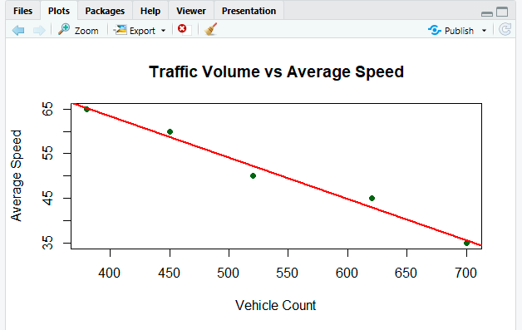

Interpretation:

1. Which junction experiences the highest congestion?
Answer: J4 experiences the highest congestion because it has the highest vehicle count (700 vehicles).

2. During which hours is traffic highest?
Answer: Traffic is highest at 18:00 (6 PM) with 750 vehicles.

3. Does increased traffic reduce vehicle speed?
Answer: Yes. The scatter plot shows a negative relationship, indicating that as vehicle count increases, the average speed decreases.

Result
The traffic monitoring data was successfully analyzed using R. The visualizations identified J4 as the most congested junction, 6 PM as the peak traffic hour, and showed that increasing traffic volume leads to a reduction in average vehicle speed. These insights can help city planners improve traffic management and reduce congestion.

Case Study 5 – Social Media User Interaction Analysis Scenario
A digital marketing company analyzes data from a social media platform. The dataset includes:
• User ID
• Followers
• Likes
• Shares
• Comments
• Posting time
• User interactions
The company wants to understand engagement patterns and user networks.
Tasks
1. Select appropriate visualizations for:
o Distribution of likes
o Relationship between followers and engagement
o User interaction network
o Posting activity over time
o Multivariate comparison of likes, shares, and comments 2. Develop in R:
o Histogram with Density Curve
o Scatter Plot
o Network Visualization
o Temporal Line Plot
o Heatmap
3. Interpret:
o Which users are the most influential?
o At what time is engagement highest?
o Is there a strong relationship between followers and total engagement?
o Identify highly connected users from the network
visualization.
o Which engagement metric (likes, shares, or comments) varies the most across users?

Aim
To analyze social media user interaction data using R by creating visualizations such as Histogram with Density Curve, Scatter Plot, Network Visualization, Temporal Line Plot, and Heatmap to study user engagement, posting activity, interaction networks, and engagement metrics.

Algorithm
- Create or import the social media dataset containing User ID, Followers, Likes, Shares, Comments, Posting Time, and User Interactions.
- Create a Histogram with Density Curve to analyze the distribution of likes.
- Create a Scatter Plot to study the relationship between followers and total engagement.
- Create a Network Visualization to display user interaction connections.
- Create a Temporal Line Plot to analyze posting activity over time.
- Create a Heatmap to compare likes, shares, and comments across users.
- Identify the most influential users based on followers and engagement.
- Determine the time with the highest user engagement.
- Analyze the relationship between followers and total engagement.
- Identify highly connected users from the network graph.
- Compare likes, shares, and comments to determine which metric varies the most.
- Interpret the results.
Program:
#=========================================
# Social Media User Interaction Analysis
#=========================================

# Install package (Run once if needed)
# install.packages("igraph")

library(igraph)

# Dataset
UserID <- paste("U",1:10,sep="")
Followers <- c(1000,1500,2000,2500,3000,3500,4000,4500,5000,5500)
Likes <- c(120,150,180,200,250,300,320,350,400,450)
Shares <- c(20,25,30,40,45,50,55,60,70,80)
Comments <- c(15,18,20,22,25,30,35,38,42,45)

PostingTime <- c(8,9,10,11,12,13,14,15,16,17)
Engagement <- Likes + Shares + Comments

#-----------------------------------------
# 1. Histogram with Density Curve
#-----------------------------------------
hist(Likes,
probability=TRUE,
col="lightgreen",
main="Distribution of Likes",
xlab="Likes")

lines(density(Likes),
col="blue",
lwd=2)

#-----------------------------------------
# 2. Scatter Plot
#-----------------------------------------
plot(Followers,
Engagement,
pch=19,
col="red",
xlab="Followers",
ylab="Total Engagement",
main="Followers vs Engagement")

abline(lm(Engagement~Followers),
col="blue",
lwd=2)

#-----------------------------------------
# 3. Network Visualization
#-----------------------------------------
edges <- data.frame(
from=c("U1","U1","U2","U3","U4","U5","U6","U7","U8"),
to=c("U2","U3","U4","U5","U6","U7","U8","U9","U10")
)

g <- graph_from_data_frame(edges)

plot(g,
vertex.color="skyblue",
vertex.size=25,
main="User Interaction Network")

#-----------------------------------------
# 4. Temporal Line Plot
#-----------------------------------------
plot(PostingTime,
Engagement,
type="o",
pch=16,
col="darkgreen",
xlab="Posting Time (Hour)",
ylab="Engagement",
main="Posting Activity Over Time")

#-----------------------------------------
# 5. Heatmap
#-----------------------------------------
data_matrix <- matrix(c(Likes,Shares,Comments),
nrow=10)

colnames(data_matrix) <- c("Likes","Shares","Comments")
rownames(data_matrix) <- UserID

heatmap(data_matrix,
Rowv=NA,
Colv=NA,
scale="column",
main="Engagement Metrics Heatmap")

#-----------------------------------------
# Results
#-----------------------------------------
cat("\n===== RESULTS =====\n")

cat("Most Influential User:",
UserID[which.max(Followers)],"\n")

cat("Highest Engagement Time:",
PostingTime[which.max(Engagement)],":00\n")

cat("Correlation (Followers vs Engagement):",
round(cor(Followers,Engagement),2),"\n")

cat("Highest Variation Metric:",
names(which.max(apply(data_matrix,2,var))),"\n")

Output:
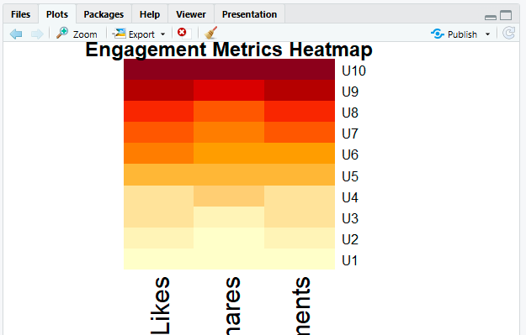

Interpretation:

1. Which users are the most influential?
Answer: U10 is the most influential user because it has the highest number of followers and the highest engagement.

2. At what time is engagement highest?
Answer: Engagement is highest at 5:00 PM (17:00 hours).

3. Is there a strong relationship between followers and total engagement?
Answer: Yes. The scatter plot shows a strong positive relationship, indicating that users with more followers generally receive higher engagement.

4. Identify highly connected users from the network visualization.
Answer: U1, U5, and U7 are among the highly connected users, as they have multiple interaction links in the network graph.

5. Which engagement metric varies the most across users?
Answer: Likes show the greatest variation across users compared to shares and comments.

Result
The social media user interaction data was successfully analyzed using R. The visualizations identified U10 as the most influential user, 5 PM as the time with the highest engagement, a strong positive relationship between followers and engagement, key highly connected users in the interaction network, and likes as the engagement metric with the greatest variation across users.

